**Release of Stop Payment**

This workflow allows a user to select, and automatically release, a stop payment from a customer’s account in Silverlake. It also gives the ability for Deposit Services to review a Stop Payment release for a customer’s account with non-post items present, prior to the Stop Payment being removed from Silverlake.

# **Starting a Workflow – Option 1**

* Choose **Workflow Queue**

* Choose **Start a Workflow** from the top menu bar.

* Choose **Release of Stop Payment**.

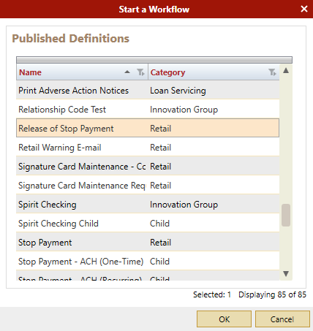

# **Starting a Workflow – Option 2**

* Open **Workflow Queue** (leave this open throughout the day for processing)
* Open **Xperience**
* **Search** for the account on the Customer & Account Inquiry screen
* Click on desired customer in the search results.
* The customer Inquiry tab displays the Customer’s Information. Click the **Start Workflow icon** at the top right of the screen.

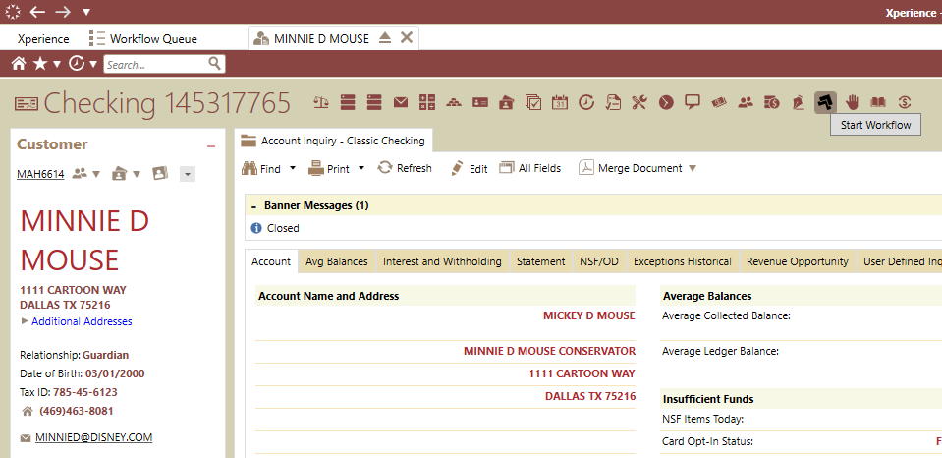

* Choose **Release of Stop Payment**

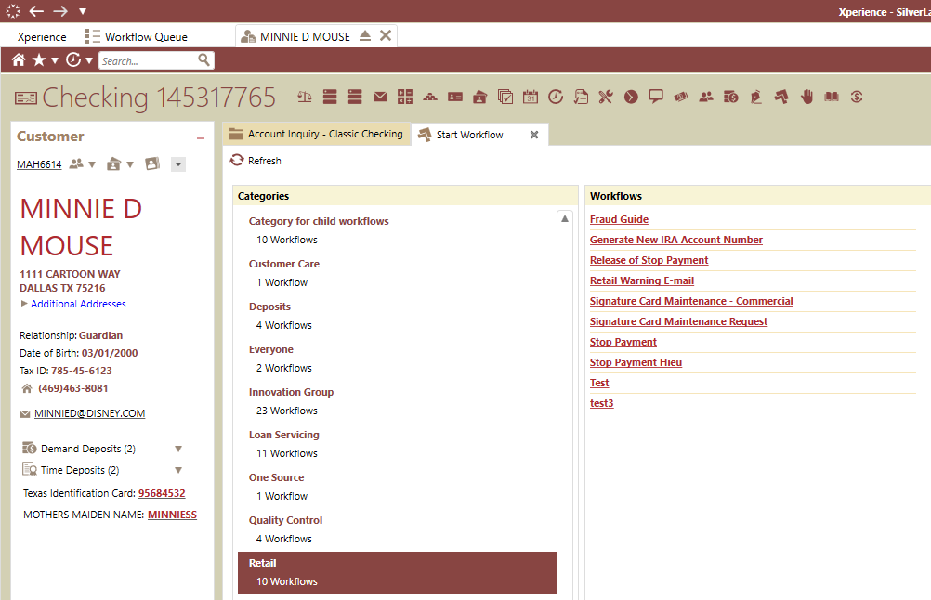

* Choose OK,

# **Completing Workflow - Retail**

* Enter the details needed in each Manual Activity, once all details are input, Click ***Complete***

*Notes: Questions with * are required. A green checkbox will prefill once the field is completed/verified.*

* + Enter Account Number (Note: if started from Customer’s account in Silverlake, this will be auto filled.)

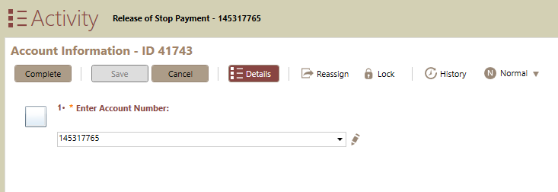

* + Fill in Stop Payment Details *If item is present on non-post, select “yes” so Deposit Services may review prior to removal from Silverlake. An item on non-post can shortly delay, or stop, the Stop Payment from being released in Silverlake*

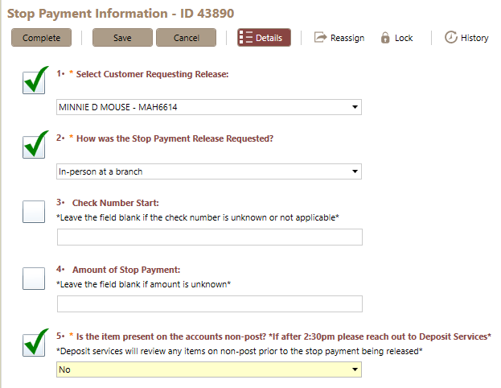

* + Select Stop Payment to Release *If no amount or Check # is entered, the drop down will display up to the first 50 stop payments on the customer’s account. If more than 50 Stop Payments are on the account, and the one you need is not displaying, choose “Reenter Stop Payment Information” to go back and add amount and/or Check # to limit the results in the drop down*

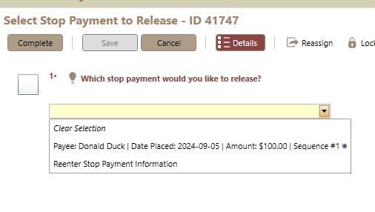

* If the Stop Payment item is not on non-post, the Stop payment will be removed from the customer’s account in Silverlake and the **workflow will end**
  + If the Stop Payment is on non-post, and Deposit Services choose to not release the stop. An email will be sent to the originator of the Release of Stop Payment letting them know the Stop Payment was not released and no further action is needed

# **Completing Workflow – Deposit Services non-post Review**

* Enter the details needed, once all details are input, Click ***Complete***
  + Review Release of Stop Payment for Non-Post Item *Choosing “yes” to continue will remove the Stop Payment from Silverlake. Choosing “no” will leave the Stop Payment in Silverlake

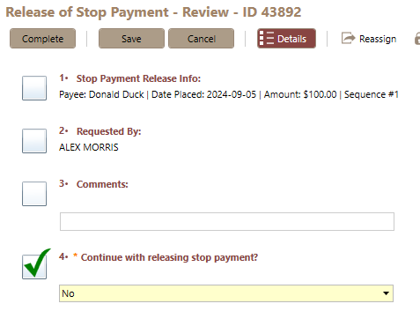

# **Synergy Audit Trail Document**

* Completed Release of Stop Payment Audit Trail

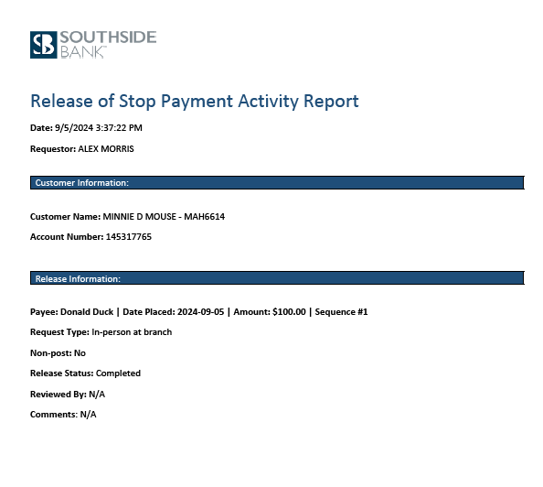

* Incomplete Release of Stop Payment

